Forgery detection algorithm – Code summary

Written by: Ido Yerushalmy

Table of Contents:

Abstract 2
Package contents 2
Code Overview 3
Running the code 4

Abstract
This document describes the implementation of the following algorithms:
- The algorithm depicted in the thesis “Digital Image Forgery Detection Based on Lens and Sensor Aberration”.
- The algorithm depicted by M. K. Johnson and H. Farid in: “Exposing Digital Forgeries Through Chromatic Aberration” (which was used for comparison purposes).

Package contents
- Under “Thesis Algorithm” folder:
  - findAberrations.m
  - analyzeLine.m
  - disFrmImgCntr.m
  - analyzeCroppedImage.m
  - medoutlierfilt.m
  - overlayContourOnImage.m
- Under “Farid/ FaridAlg/ FaridAlg” folder:
  - faridAlg.cpp
  - faridAlg.h
  - FaridAlg.vcproj
  - EasyBMP.cpp
  - EasyBMP.h
  - easybmp_bmp.h
  - EasyBMP_DataStructures.h
  - easybmp_variousbmputilities.h
- imagesNames.txt
- sample_image.jpg
- sample_image_croppedRight.jpg
- FaridImagesNames.txt

Detailed description of the contents of each file and the underlying functions is embedded at the head of every file.

Code Overview
The code used to test the capabilities of the algorithm presented in the above thesis was written under MATLAB 7.4. The code is compromised of a main script (findAberrations.m) which uses several utility functions. The script receives a file describing the images to be analyzed and for each image generates the following outputs:
- A MATLAB figure which displays the analyzed image, overlaid with significant PBA arrows and forgery-suspected regions.
- A text file with numeric results (line per image).

To compare the results to the algorithm proposed by Johnson and Farid, additional code was written in C++ and compiled using Visual-Studio 2005 (Version: 2.0.50727 SP1). This code follows the definitions in the paper. It receives a file describing the images to be analyzed and outputs the numeric results to a text file.

Both the MATLAB script and the C++ code results files can be imported into Excel to perform easy analysis of the data (detailed explanation follows).

Running the code
Thesis algorithm – (Non-cropped images):
- In MATLAB, go to file->set-path and add the location of the file “imagesNames.txt” and that of ‘sample_image.jpg’.
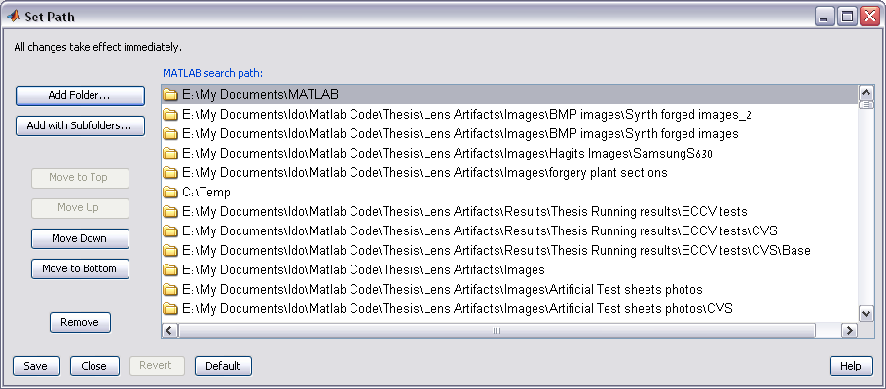
- Open ‘imagesNames.txt’.
  - The row which follows the ‘savePathDir’ line defines the location in which the results will be saved. Change ‘C:\temp\’ to the folder in which you wish to save the results.
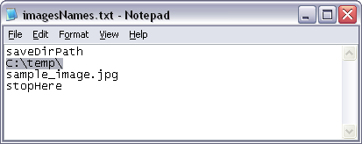
  - Following the destination folder name, a list of images to be analyzed appears; a line per image. This list must be terminated by the string ‘stopHere’. Note that any images that appear after this string will not be processed by the script.
- In MATLAB, open the file ‘findAberrations.m’ and run it (F5). The sample image will be displayed with arrows indicating the PBA directions added to it as the algorithm proceeds. An indicator of the percentage of work completed will be displayed at the command window of MATLAB.
- Once the analysis is done, 2 significant results would available at the folder defined in step (2) above:
  - A figure (sample_image.fig) with:
    - Suspected forged regions marked in blue
    - Calculated center location marked in green. There is a green dot per iteration of the outliers removal. As the iterations increase the dot gets bigger. In the example below the center did not change its location between the iterations, so only a single green dot can be seen.
    - Arrows which indicate the PBA direction and strength.
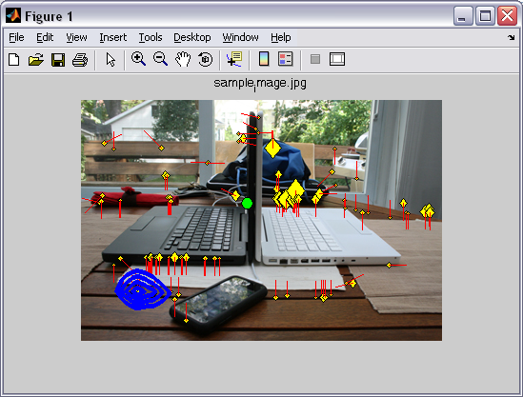
  - The numeric results under ErrorLog.txt. See line 570 in ‘findAberrations.m’ for details about the values saved in the file. To export the numeric values to an Excel worksheet, copy the contents of the file and use the ‘text import wizard’ to set it correctly in the worksheet (choose the ‘comma’ as the delimiter instead of ‘space’):
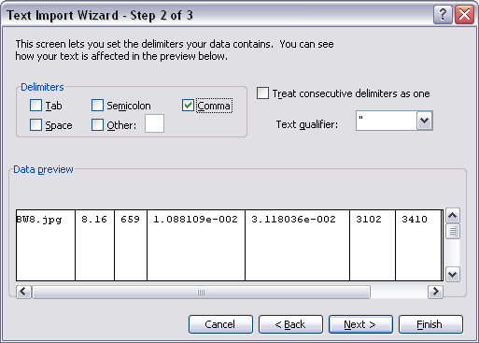

Thesis Algorithm – Testing cropped images:
- In ‘findAberrations.m’ file set the following:
  - ‘analyzeCroppedImages’ (line 54) to 1.
  - ‘cropPercentage’ (line 56) to the part of the image which was cropped. In ‘sample_image_croppedRight.jpg’, the cropped section was 1/3 of the original image.
- In ‘imagesNames.txt’ change the image to be analyzed to ‘sample_image_croppedRight.jpg’.
- Follow the steps described above (for non-cropped images).
- Once the analysis is done, 2 significant results would available at the folder defined:
  - A figure (sample_image_croppedRight.fig) with:
    - Suspected forged regions marked in blue
    - Calculated center location marked in green. There is a green dot per iteration of the outliers removal. As the iterations increase the dot gets bigger.
    - Original geometric center in red
    - Arrows which indicate the PBA direction and strength
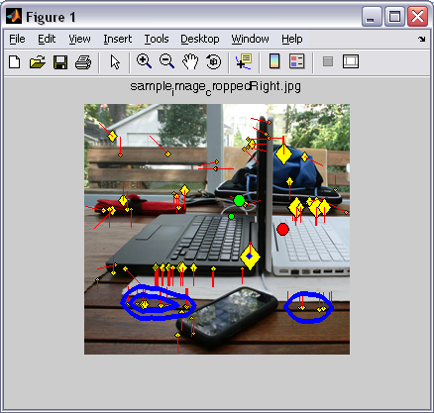
  - The numeric results under ‘coppedRatioLog.txt’. See line 178 in ‘analyzeCroppedImage.m’ for details about the values saved in the file.

Farid’s algorithm:
Note: this code works only for bmp type images.

- Open the solution ‘FaridAlg’ under Microsoft visual studio 2005.
- Open file ‘faridAlg.cpp’ and set the following:
  - C_WORKING_DIRECTORY (line 25) to the folder which contains the images to test and the file with the images names.
  - C_IMAGES_FILE_NAME (line 26) to the file name which contains the images to be analyzed. This file should contain a single image name per row (see ‘FaridImagesNames.txt’ for example).
- In line 86 of ‘faridAlg.cpp’, set the type of analysis you wish to perform on the images:
  - ‘regular’ – for authentic images
  - ‘croppedImages’ – for cropped images
  - ‘forgedImages’ – for forged images
- If working on forged images, set the ‘cropPercentage’ value as appropriate (similar to the MATLAB implementation).
- Compile the code, preferably in optimized mode (O2) to assure faster results.
- Run the executable. A text file with numeric results is generated (‘Result_file.txt’). The content of the file is explained at the file’s header. To export the numeric values to an Excel worksheet, copy the contents of the file and use the ‘text import wizard’ to set it correctly in the worksheet (choose the ‘comma’ as the delimiter instead of ‘space’):
- In addition a folder named ‘SW debug’ is created, under which you may find a text file with logs of warnings / errors.

